As it is described in the Amazon official documentation link [here](http://docs.aws.amazon.com/lambda/latest/dg/lambda-python-how-to-create-deployment-package.html) It is as simple as just creating a zip of all the folder contents after installing the required packages in your folder where you have your python lambda code.

As Vineeth pointed above in his comment, The very first step in moving from an inline code editor to a zip file upload approach is to change your lambda function handler name under configuration settings to include the python script file name that holds the lambda handler.

**lambda_handler => {your-python-script-file-name}.lambda_handler**.

[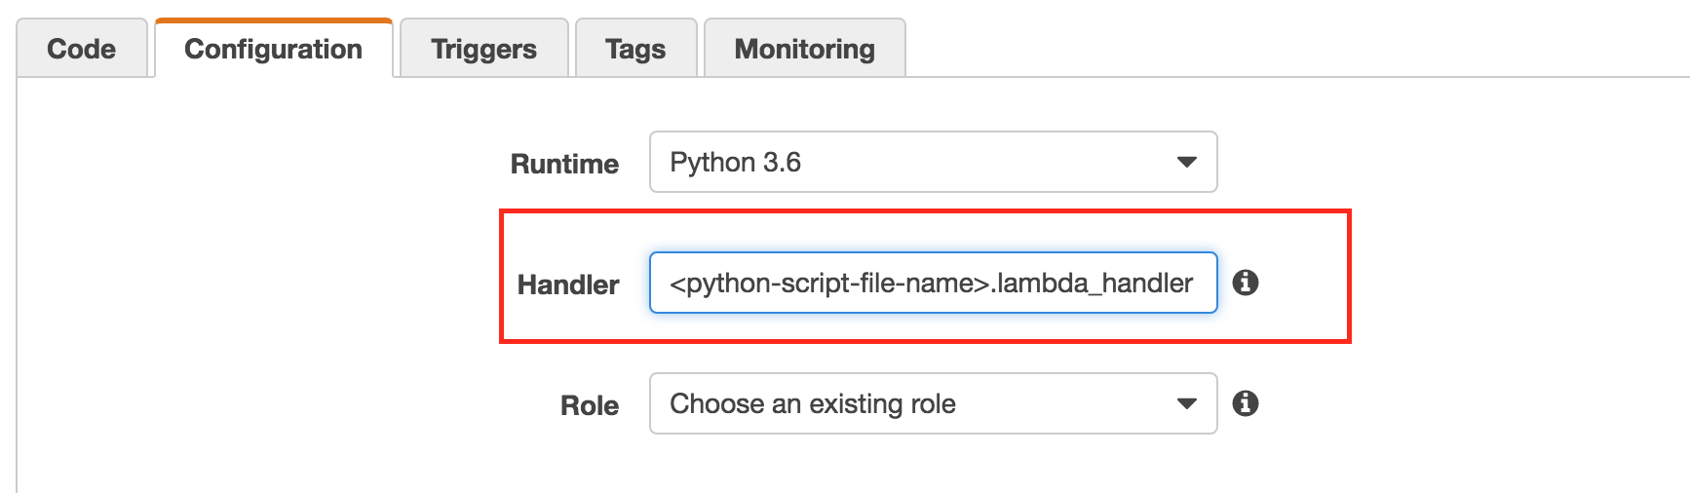](https://i.stack.imgur.com/D3bd0.png)